**Lab 2: Calculation of Internal Resistance of Voltmeter, Ammeter, and Scope**

**Lab Report by: Talal Jawaid**

**Lab Session: Wednesday**

**Due Date of the Lab: 2/21/18**

**Date(s) of the lab: 2/14/18**

**Lab partner(s): Sergio Zavala and Amrit Singh**

1. **Introduction**

In this Lab we learn how to design a circuit to model a Voltmeter, Ammeter, and Scope so that we can calculate the internal resistance of these meters. The meter circuits are connected to the output nodes of the circuit which we are measuring. We used two different

1. **Purpose**

The purpose of this lab is to make us better at visualizing at how a meter, whether it measures voltage or current, should be connected into a system and how it should be considered when calculating for values within the circuit. This helps us understand how the internal resistance of the voltmeter or ammeter affects the values measured within a circuit.

1. **Discussion and Results**

**Part1:**

**Procedure:**

For this part of the lab, we simply designed a circuit that had a voltage source and a resistor load. We had to use a circuit where we could easily determine the internal resistance of the ammeter. Another requirement was that our load resistor had to be higher than the internal resistance of the supply circuit. So we constructed a circuit with two resistors of around 10 ohms each in parallel with each other and then wired the ammeter in series with them. The voltage source was set to 1.0 volts.

**Data:**

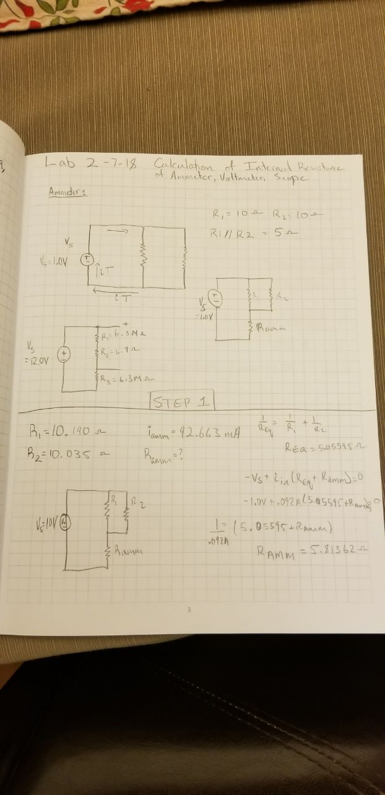



**Analysis:**

This is the circuit we created. As you can see it has a voltage of 1.0 volts and we used two resistors in parallel with each other with a resistance of around 10 ohms each. We then connected the ammeter in series with both resistors. As we had the values for the current and resistance of both resistors, as well as the voltage of the source, it was a simple calculation to solve for internal resistance of the ammeter.

The internal resistance of the ammeter was found to be 5.817 ohms.

**Part 2:**

**Procedure:**

For this part of the lab, we wired three resistors in series with each other and then wired the voltmeter in parallel with the first two resistors. This would allow us to solve for the internal resistance of the voltmeter. We also used the oscilloscope to measure the voltage across the two resistors in series so that we could calculate the internal resistance of the oscilloscope as well.

**Data:**

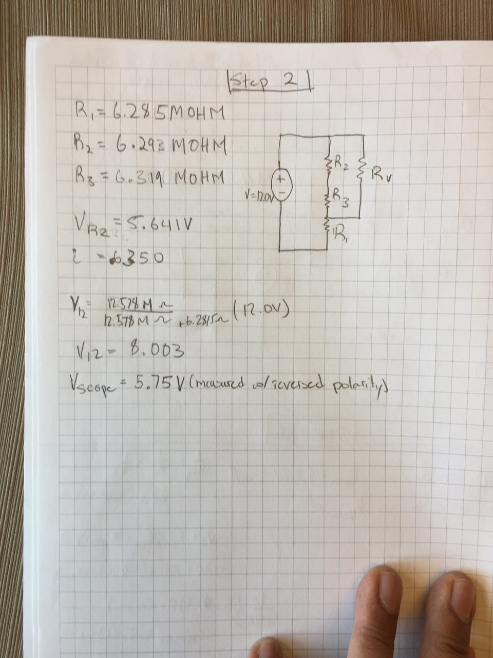

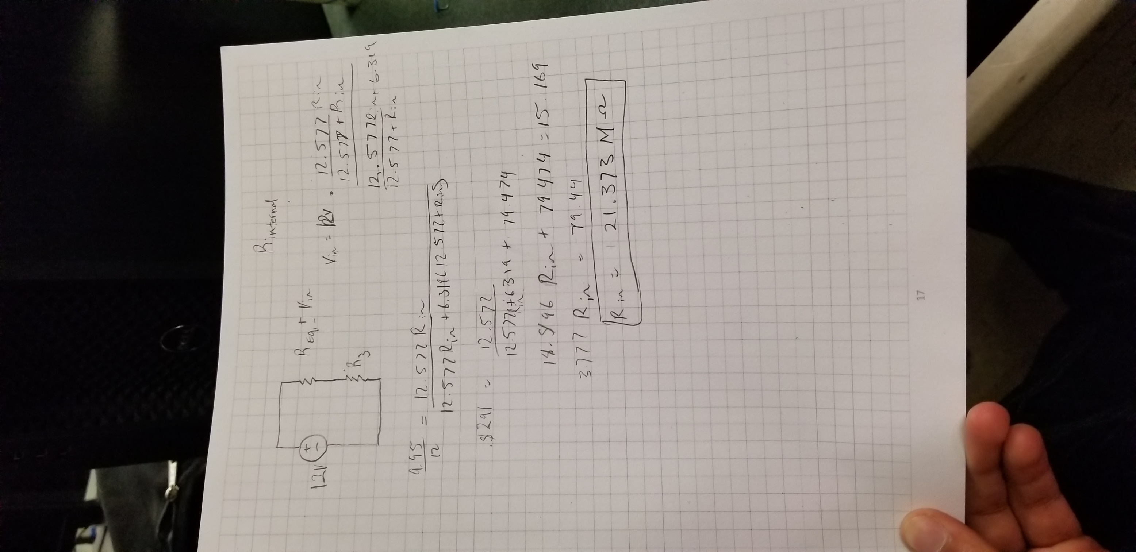



**Analysis:**

We measured our resistors to be all around 6.3 mega ohms. The voltage across the two resistors R2 and R3 in our circuit was measured to be 8.003 volts. Using the scope it was measured to be 5.75 volts with reversed polarity. We could not figure out why the voltage was so different from the scope to the voltmeter. We then applied voltage division to solve for the internal resistance of the voltmeter. Through this analysis, we determined the internal resistance to be around 21 mega ohms. This value makes sense as the lab manual states that the load resistor should have a higher resistor than the resistance of the supply circuit.

1. **Conclusion:**

In conclusion, we were able to accurately solve for the internal resistances of the voltmeter and the ammeter by constructing circuits which obeyed the KVL and KCL laws, as well as voltage division. Through the use of the known values of the resistors and supply voltages, we were able to solve for internal resistance. While the internal resistance of the ammeter was simple to find through a small equation, the internal resistance of the voltmeter was difficult to find. As measured, the internal resistance of the ammeter was very low, nearly 5 ohms, while the internal resistance of the voltmeter and scope was very high as expected, about 21 mega ohms, in the high mega ohm range.